TASK 4 – TICKET BOOKING SYSTEM

1. Calculate the Average Ticket Price for Events in Each Venue Using a Subquery.

SELECT v.venue_id, v.venue_name,(SELECT AVG(e.ticket_price) FROM Event e

-> WHERE e.venue_id = v.venue_id) AS average_ticket_price FROM Venu v;

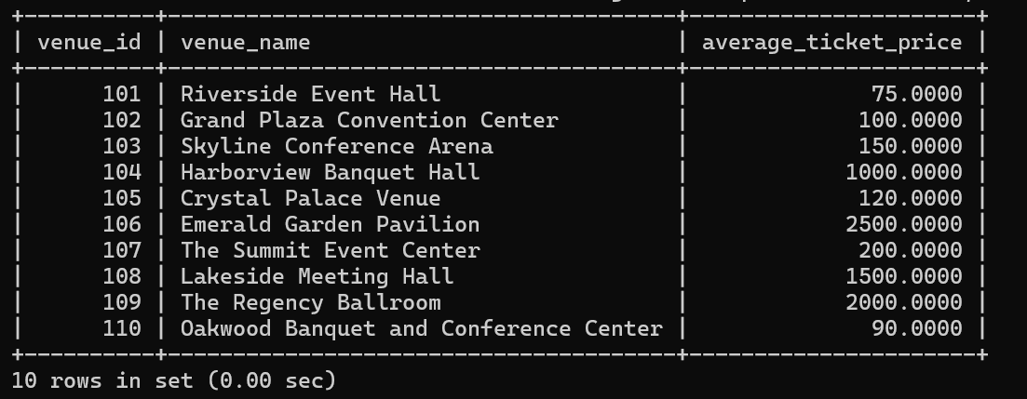

2. Find Events with More Than 50% of Tickets Sold using subquery.

mysql> SELECT event_id, event_name, total_seats, available_seats

-> FROM Event

-> WHERE (total_seats - available_seats) <= (

-> SELECT 0.5 * e.total_seats

-> FROM Event e

-> WHERE e.event_id = Event.event_id

-> );

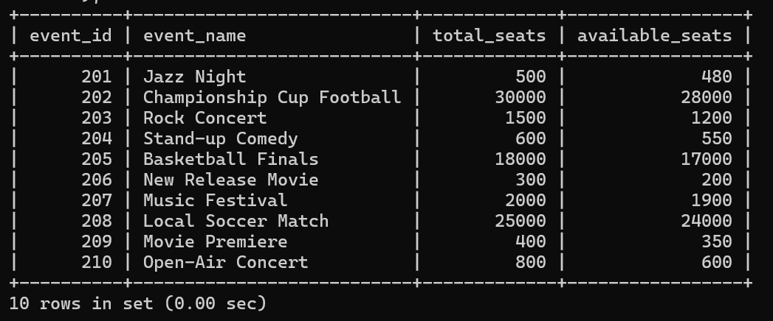

3. Calculate the Total Number of Tickets Sold for Each Event.

SELECT event_id, event_name, (SELECT total_seats - available_seats FROM Event e WHERE e.event_id = Event.event_id) AS tickets_sold

FROM Event;

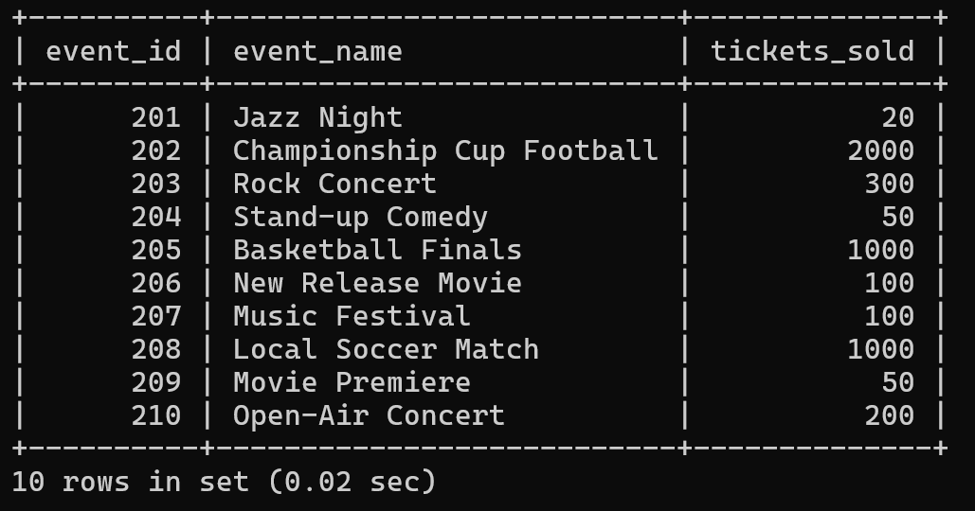

4. Find Users Who Have Not Booked Any Tickets Using a NOT EXISTS Subquery.

mysql> SELECT c.customer_id, c.customer_name

-> FROM Customers c

-> WHERE NOT EXISTS (

-> SELECT b.customer_id

-> FROM Booking b

-> WHERE b.customer_id = c.customer_id

-> );

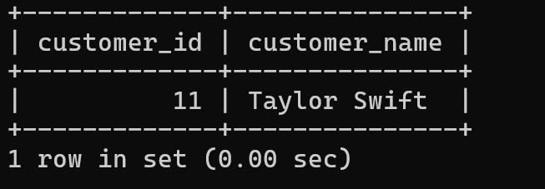

5. List Events with No Ticket Sales Using a NOT IN Subquery.

mysql> SELECT e.event_id, e.event_name, e.total_seats, e.available_seats

-> FROM Event e

-> WHERE e.event_id NOT IN (

-> SELECT b.event_id

-> FROM Booking b

-> );

6. Calculate the Total Number of Tickets Sold for Each Event Type Using a Subquery in the FROM Clause.

mysql> SELECT e.event_type, SUM(tickets_sold) AS total_tickets_sold

-> FROM (

-> SELECT event_id, event_type, (total_seats - available_seats) AS tickets_sold

-> FROM Event )

-> AS e

-> GROUP BY e.event_type;

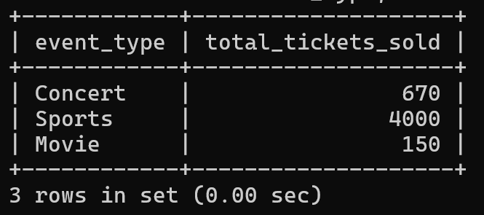

7. Find Events with Ticket Prices Higher Than the Average Ticket Price Using a Subquery in the WHERE Clause.

mysql> SELECT event_id, event_name, ticket_price

-> FROM Event

-> WHERE ticket_price > (

-> SELECT AVG(ticket_price)

-> FROM Event

-> );

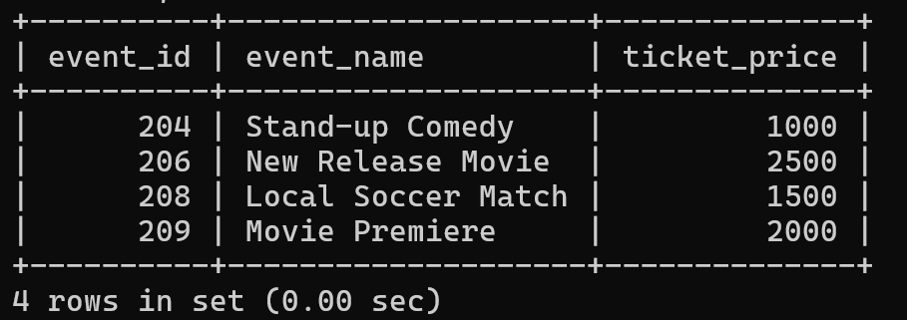

8. Calculate the Total Revenue Generated by Events for Each User Using a Correlated Subquery.

mysql> SELECT c.customer_id, c.customer_name, (SELECT SUM(b.num_tickets * e.ticket_price)

-> FROM Booking b

-> INNER JOIN Event e ON b.event_id = e.event_id

-> WHERE b.customer_id = c.customer_id ) AS total_revenue

-> FROM Customers c;

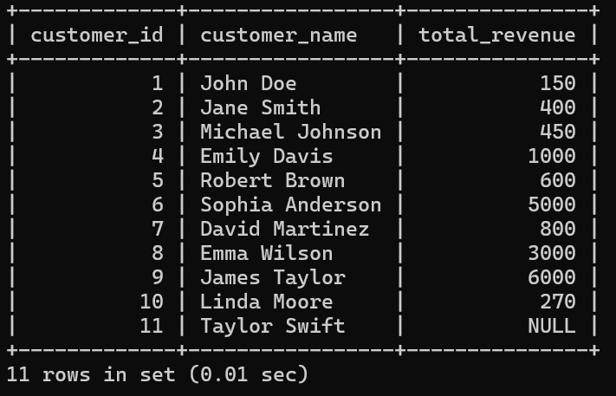

9. List Users Who Have Booked Tickets for Events in a Given Venue Using a Subquery in the WHERE Clause.

mysql> SELECT c.customer_id, c.customer_name, c.email, c.phone_number

-> FROM Customers c

-> WHERE c.customer_id IN (

-> SELECT b.customer_id

-> FROM Booking b

-> WHERE b.event_id IN (

-> SELECT e.event_id

-> FROM Event e

-> WHERE e.venue_id = 101

-> )

-> );

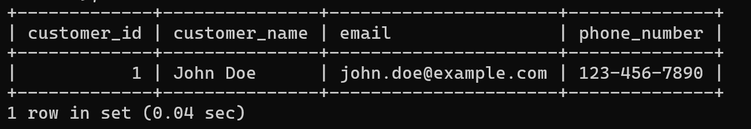

10. Calculate the Total Number of Tickets Sold for Each Event Category Using a Subquery with GROUP BY.

mysql> SELECT e.event_type,

-> SUM(b.num_tickets) AS total_tickets_sold

-> FROM Event e

-> LEFT JOIN Booking b ON e.event_id = b.event_id

-> GROUP BY e.event_type;

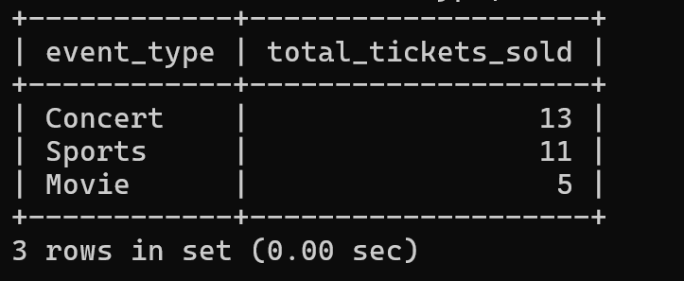

11. Find Users Who Have Booked Tickets for Events in each Month Using a Subquery with DATE_FORMAT.

mysql> SELECT c.customer_id, c.customer_name, DATE_FORMAT(b.booking_date, '%Y-%m') AS booking_month

-> FROM Customers c

-> Join Booking b ON c.customer_id = b.customer_id

-> GROUP BY c.customer_id, c.customer_name, DATE_FORMAT(b.booking_date, '%Y-%m');

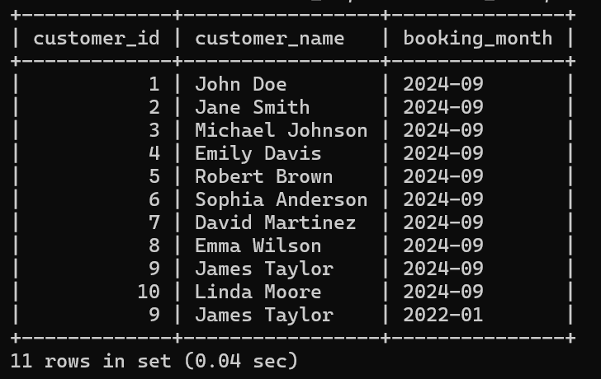

12. Calculate the Average Ticket Price for Events in Each Venue Using a Subquery

mysql> SELECT v.venue_name,

-> (SELECT AVG(e.ticket_price)

-> FROM Event e

-> WHERE e.venue_id = v.venue_id) AS average_ticket_price

-> From venu v;

